IKA WELLNESS SPA

INSTALL AND ADMINISTRATOR GUIDE

Contents

Download and extract the installer 2

Install Ika’s Wellness Spa 2

Create or Update Admin Password 5

Update Therapist List 8

Download and extract the installer

Download location of the installer can be found here: <https://raw.githubusercontent.com/balerta/bigapple/master/build/ika_wellness_spa_setup.zip>

## Install Ika’s Wellness Spa

1. Once extracted, right click setup.exe and click “Run as Administrator” to install the application.

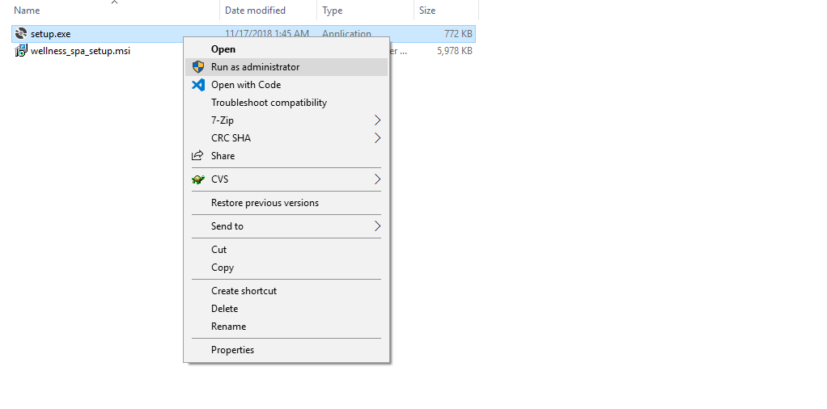

1. Click “Yes” when a dialog User Account Control pop’s up.
2. Click Next.

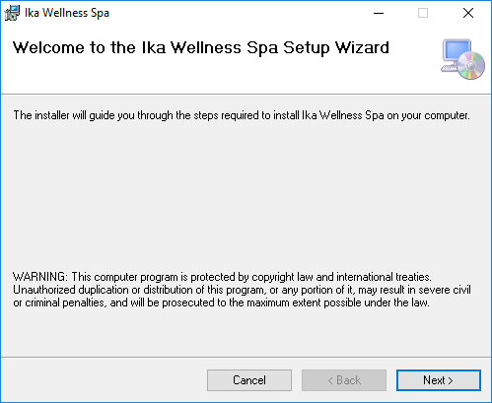

1. Leave the values as is and click Next.

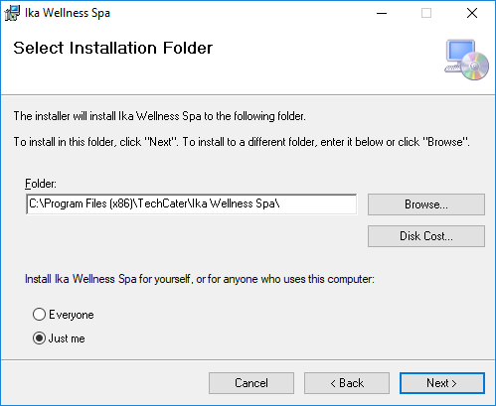

1. Click Next.

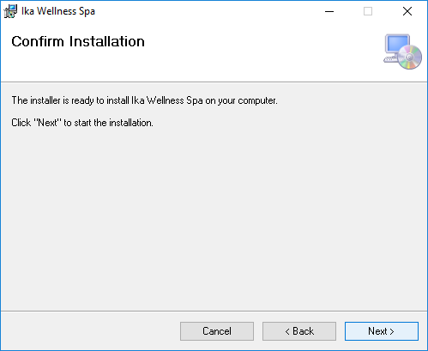

1. You should see a successful installation at the end, click Close to close the setup.

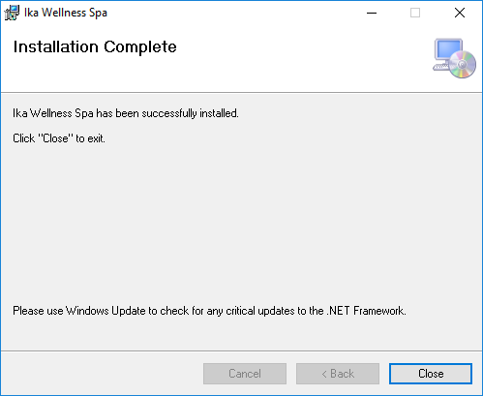

1. A Desktop shortcut of Ika’s Wellness Spa should be created and Start Menu shortcut as well.
   1. Desktop:



* 1. Start Menu:



1. You can now start the application with either of these shortcuts.

## Create or Update Admin Password

By default the install directory of Ika’s Wellness Spa is under on "C:\Program Files (x86)\TechCater\Ika Wellness Spa\".

1. Click Windows Start button



1. Search for “Run”

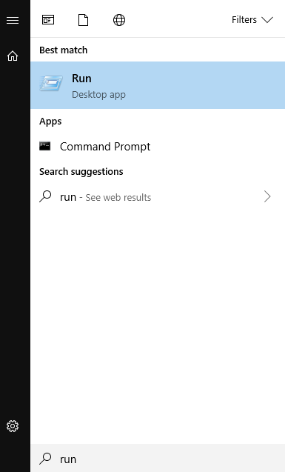

1. Click “Run”, and copy paste the install directory - "C:\Program Files (x86)\TechCater\Ika Wellness Spa\" of Ika’s Wellness Spa on the text field and click OK.

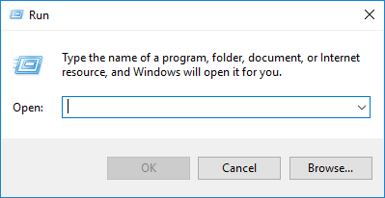

1. You’ll be redirected to the install directory of Ika’s Wellness Spa.

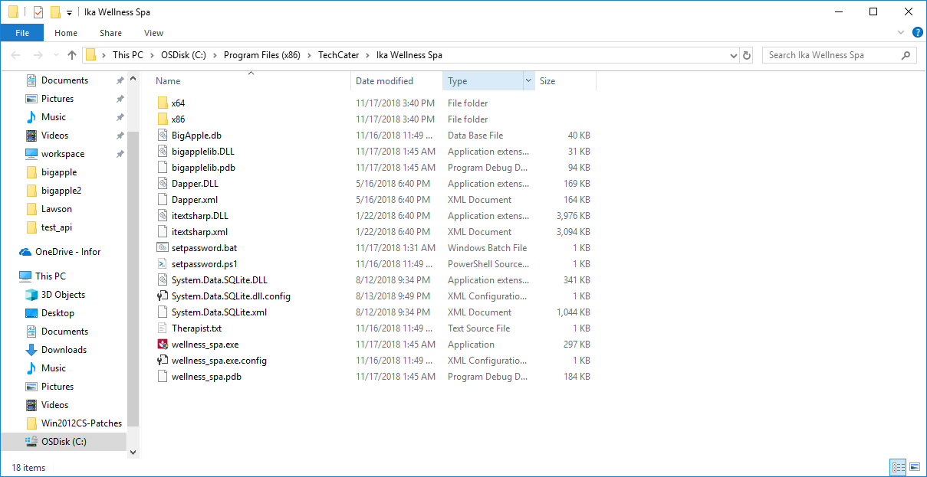

1. Double click setpassword.bat to setup an Admin Password for Ika’s Wellness Spa and enter your desire Admin Password. 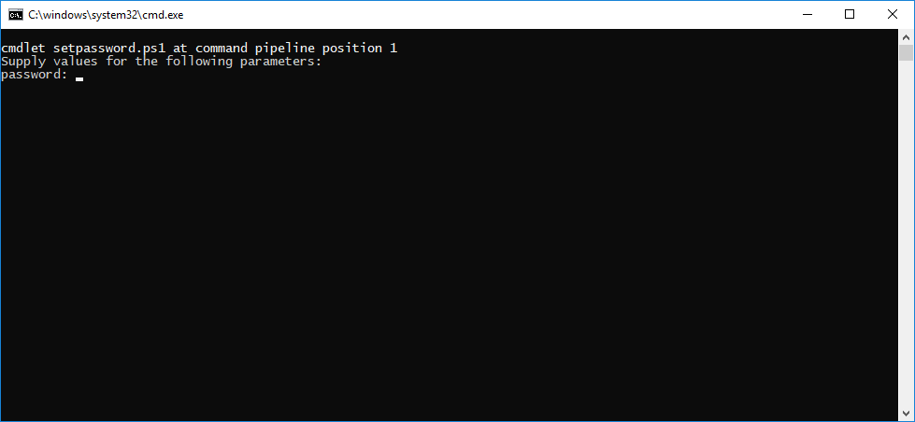
2. Once you entered your Admin Password, press enter to create\update the Admin Password. Press any key to close the program. 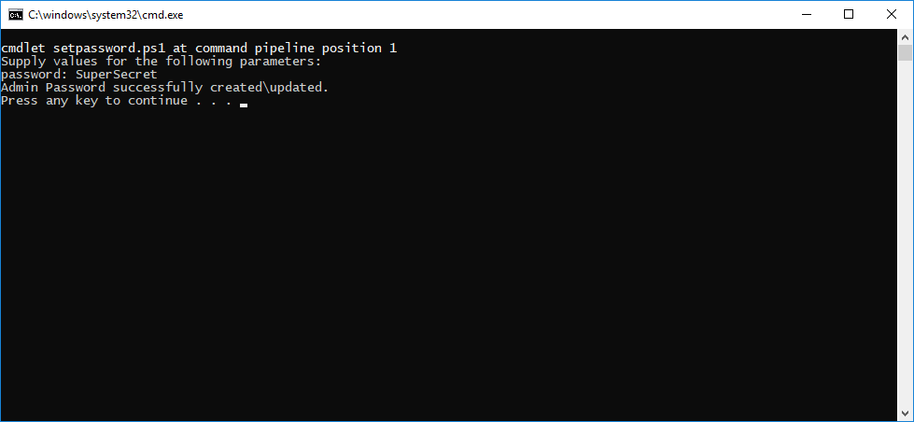
3. You now have successfully created or updated an Admin Password. You may now void sales with the set Admin Password.

## Update Therapist List

You need to close the Ika’s Wellness Spa in order to update the therapist list.

By default the install directory of Ika’s Wellness Spa is under on "C:\Program Files (x86)\TechCater\Ika Wellness Spa\".

1. Click Windows Start button



1. Search for “Notepad”, right click and click Run as Administrator.

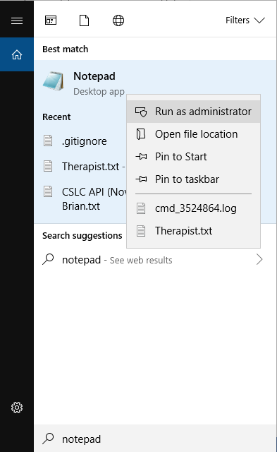

1. Click “Yes” when a User Account Control pops up.
2. Once the notepad is opened, Click File and Click Open.

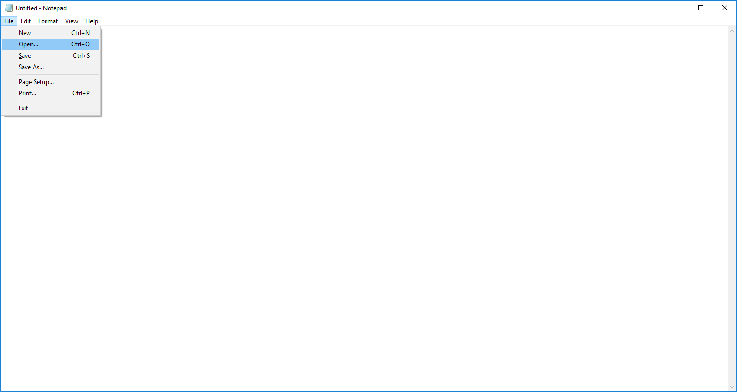

1. You can paste the install directory of Ika’s Wellness Spa on the highlighted text field below.

Install Directory: C:\Program Files (x86)\TechCater\Ika Wellness Spa

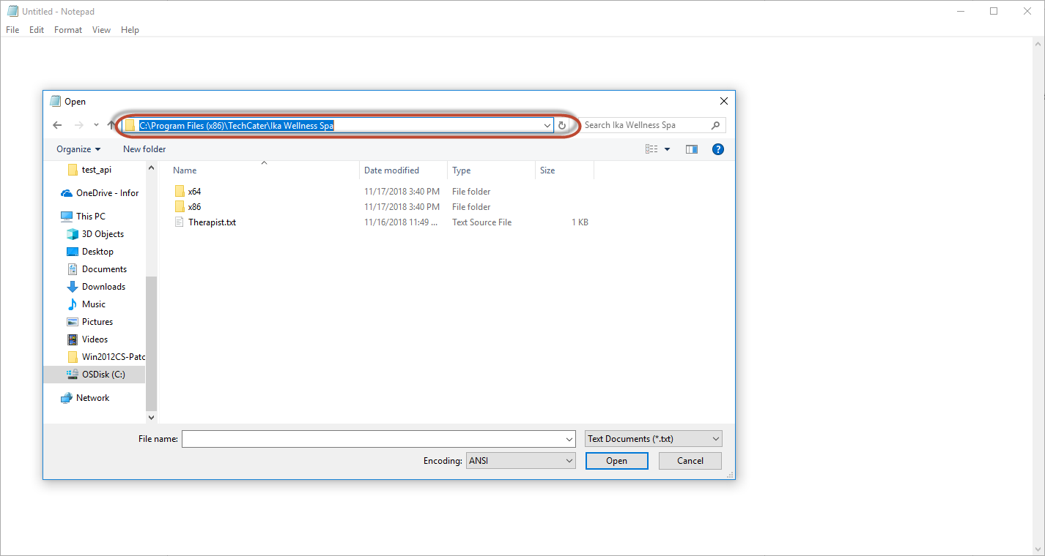

1. Choose Therapist.txt and click Open.

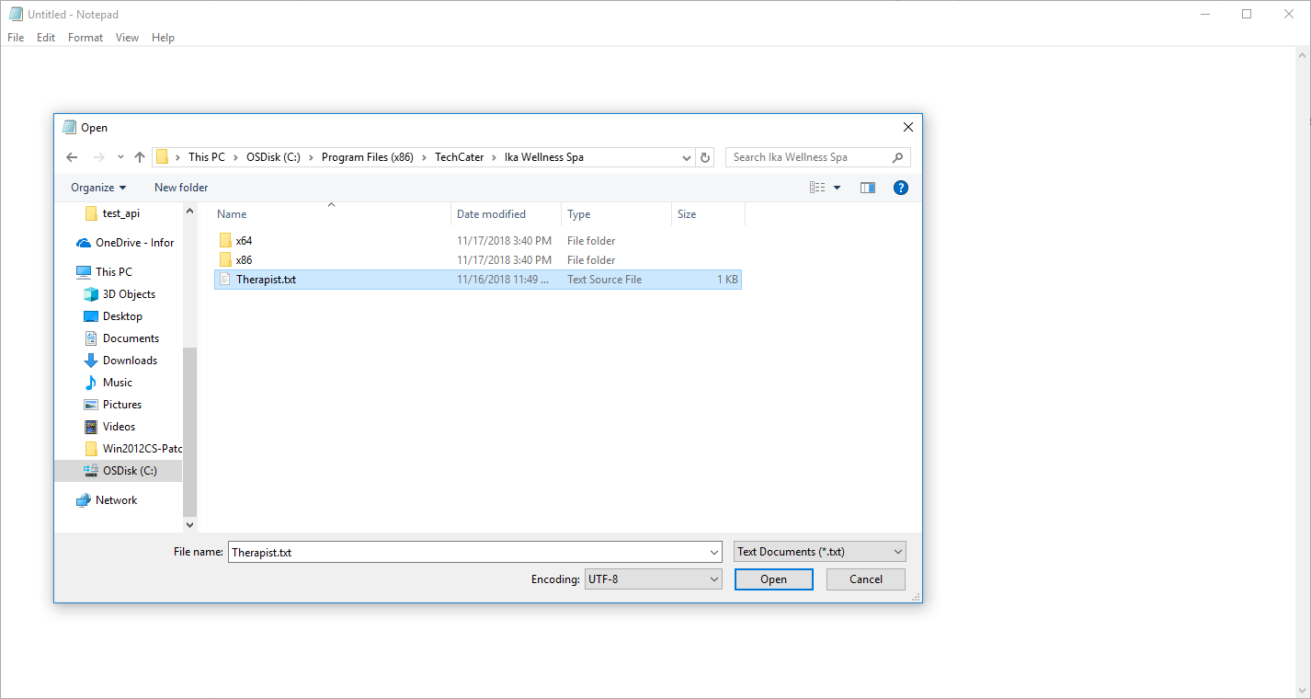

1. You can now update the Therapist list.

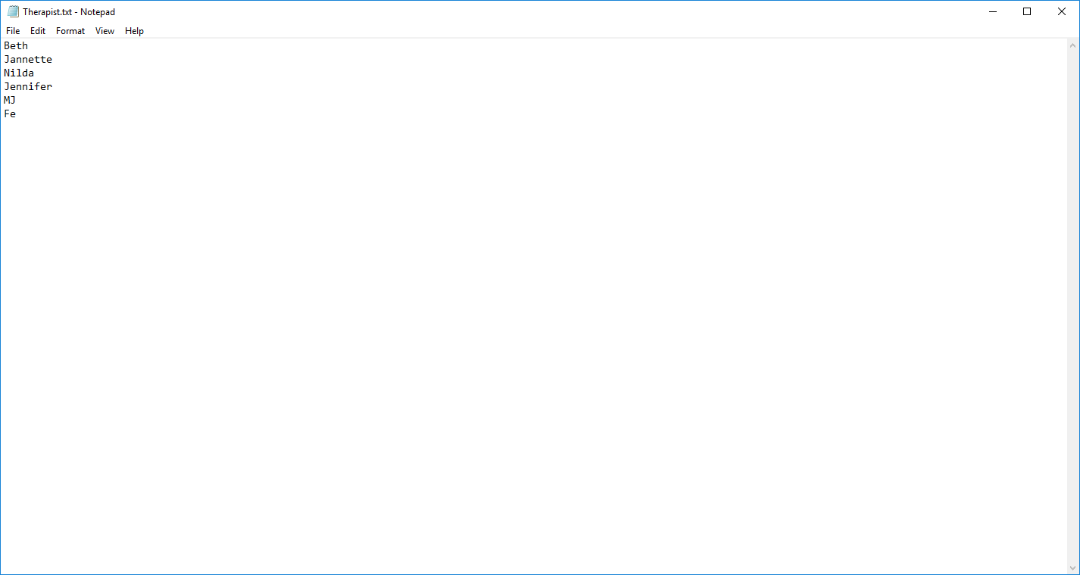

1. You can delete the existing Therapist or add a new one. Remember when adding a new Therapist is per line. Like shown on the screenshot above.
2. Once done updating the Therapist List. Click File and click save. You can now close this file and open Ika’s Wellness Spa to verify the updated Therapist List. To verify you can go to Client Receipt and Therapist Report and click the therapist list and validate if the list was updated.